Project Two Entity Relational Diagram (ERD) – Olivia Smith

Developer’s Note
This ERD is likely far from perfect, but it is what I’ve come up with so far and I believe it is at the very least a good starting point. Please feel free to ask questions and give feedback on it and make your concerns known to me and the rest of the group. YOUR OPINION MATTERS!!
It has been a bit since I took the first database course, and I did not take it here at ETSU. So, if there are any errors or things that look off, please let me know as soon as possible.

Entity Relational Diagram

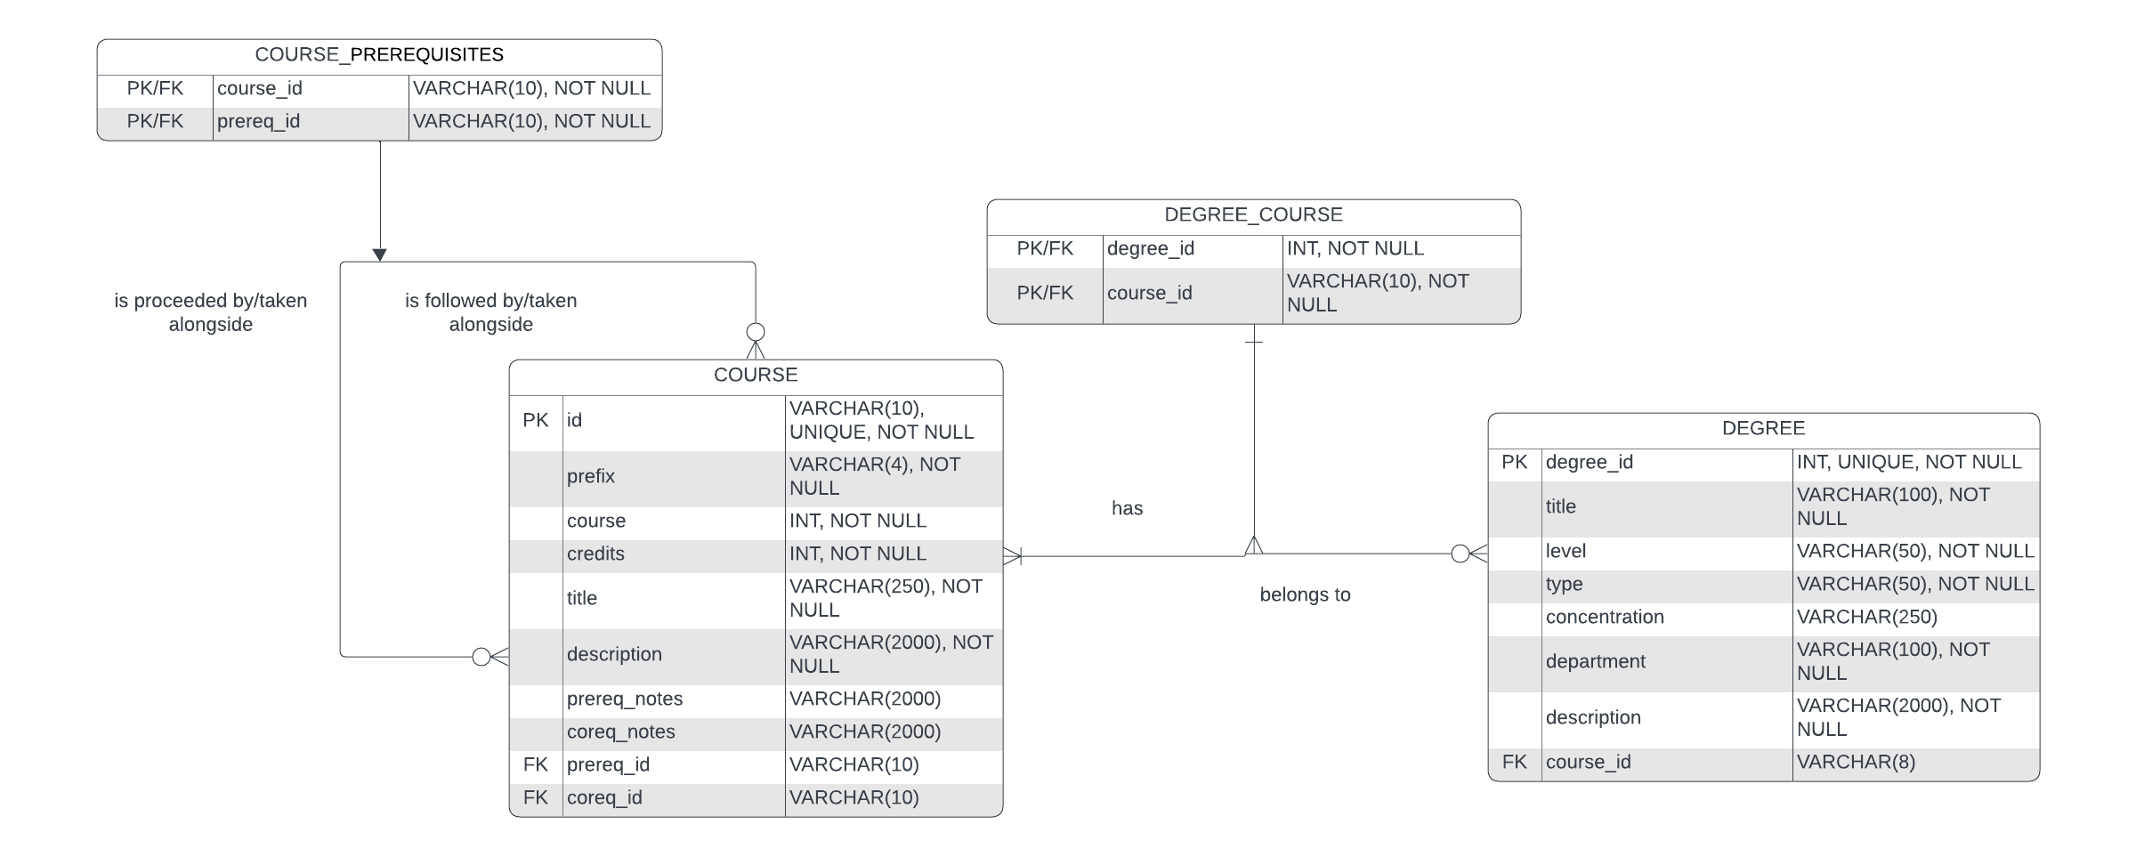

Structure Assumptions

- A COURSE can have zero to many prerequisite COURSES
- A prerequisite COURSE can proceed zero to many COURSES
- A DEGREE can have one to many COURES
- A COURSE can belong to zero to many DEGREES

Structure Notes

Regarding COURSE
A self-referencing many-to-many relationship is used with the course table to account for prerequisite courses. As a course can have no or multiple prerequisites, it can also account for any of those situations. As with any many-to-many relationship, it includes an associative entity, COURSE_PREREQUISITIES
The foreign keys on the course table are not tagged with “NOT NULL” due to some courses not having any prerequisites or corequisites. Therefore, this is optional and a key reason why on both ends of the relationship it is defined as zero-to-many.

Regarding DEGREE
A many-to-many relationship is used connect the degree table to the course table. As a degree would (clearly) require at least one course to any number of courses, it is one-to-many. The same is true for relating course back to degree, as a course can be associated with any degree, however it is not a hard requirement. Therefore, on that side it is zero-to-many. Like with course, it has an associative entity, DEGREE_COURSE.

A Note on Corequisites Courses
Corequisites courses are courses that must be taken at the same time as another course and are similar to CSCI-1100 lecture and its associated lab course. While they exist within our school, they are rather uncommon. However, the self-referencing many-to-many relationship for the course table will handle them the same as prerequisites are handling and there should be little problem with it. In the event that there is a problem due to corequisite entries, it is likely that they can be omitted.

